

Downloading and formatting the Indicator Tracker

**For the following reporting periods all CBM partners shall use the ProMIS Indicator Tracker.** The tracker export document of ProMIS is not user friendly. We have created an application that coverts the document into a user-friendly excel sheet. These are the steps to be used:

1. Export the Indicator Tracker of your project from ProMIS:

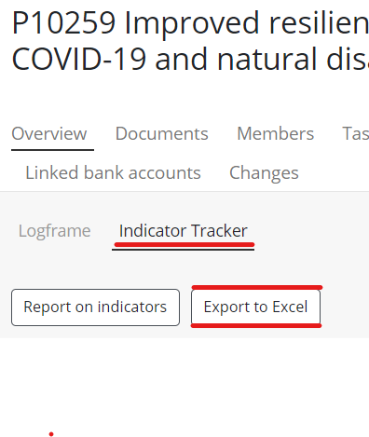

1. Check whether the downloaded document is complete – sometimes we face technical issues with the download. In such case, please approach IT Programmes for support.

**NOTE:** If a project name is too long, you may be unable to open the document. Then, you need to rename it with a shorter name with less than 100 characters. You may use the shared naming convention:

* *Initiative/Sector (Abbreviation or complete description)* – IEH, CBID, CBID PR, IHA, NTD etc.
* *Component / Specific intervention*
* *Target group*
* *Example: IEH-Outreach-Children with disability*

1. Open this Sharepoint Library: [CBM Standard Indicators - Document Library - All Documents (sharepoint.com)](https://cbm365.sharepoint.com/sites/INDIC/Document%20Library/Forms/AllItems.aspx)

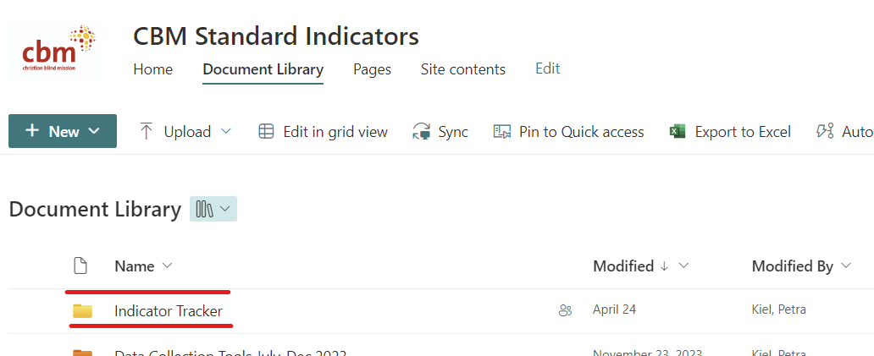

1. Upload the tracker download into that Document Library into the folder Indicator Tracker [CBM Standard Indicators - Indicator Tracker - All Documents (sharepoint.com)](https://cbm365.sharepoint.com/sites/INDIC/Document%20Library/Forms/AllItems.aspx?id=%2Fsites%2FINDIC%2FDocument%20Library%2FIndicator%20Tracker&viewid=798b2911%2D4171%2D41d5%2D86bf%2Df38e0c4b5ce9) and wait for the conversion process to work.

Your document will be here:

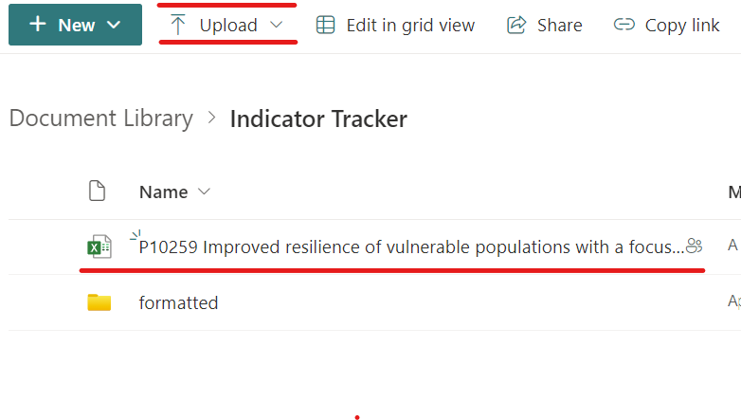

1. The document will automatically be converted to a user-friendly version – this might take a few minutes. You will receive an email once the conversion is completed. We advise to wait for the email and click on the link to open the document:

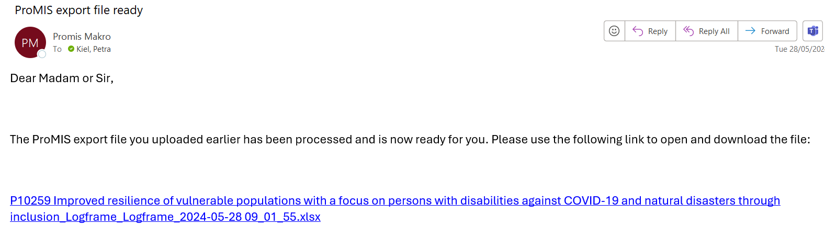

1. Once the conversion is completed, the original document will disappear from the folder “Indicator Tracker” and be stored in the folder “formatted”:

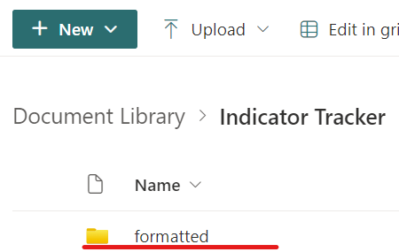

1. You can also open the formatted document from this folder.
2. Please have a final look at the converted tracker and ensure it is complete and well readable before sending to the partner.
3. We advise to store the formatted tracker in the Project Library under “03 Implementation and Monitoring” (as “tracker_original” for example) as you may need it later again. We advise to create a separate sub-folder named “Tracker” for easy reference.
4. Send the Indicator Tracker to the partner/person in charge for reporting of actuals and set a deadline for sending the completed tracker back. Deadlines are 31 July and 31 January each year for all projects besides NTD. For NTD projects the deadlines is mostly 31 March.
5. It is best to delete the formatted document from the “formatted” folder once done to avoid clogging – almost 400 trackers need to be converted.
6. If any problem arises, e.g. the tracker download is incomplete or the formatting does not work, you may wait and try again after a few minutes.
7. For any other issues, please contact IT Programmes for support.

**NOTES:**

* Firstly, train partners on the use of the tracker, incl.
  1. Recap on how and what to count – you may involve technical advisors as needed;
  2. Reporting actuals within the correct reporting period;
  3. Taking care of correct insertion of all disaggregated numbers.
* **Secondly, all incoming completed tracker needs to undergo a quality control before transferring its data into ProMIS and before storing the correct and final version in the project library.**
* You may store the final version for the first reporting period with the name ending on: “tracker 1_2024” and the second as “tracker 2_2024” etc.